Contains:

//a[contains(text(), ‘features’)]

//button[contains(text(), ‘Signup’)]

#using and in xpath

//button[@type=’button’ and @class=’btn’]

Parent to child

//div//button[@type=’button’]

Child to parent

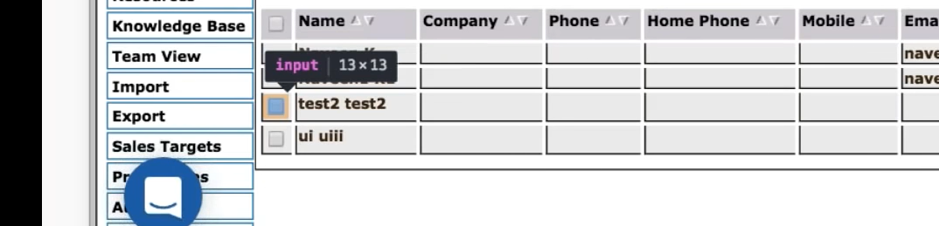



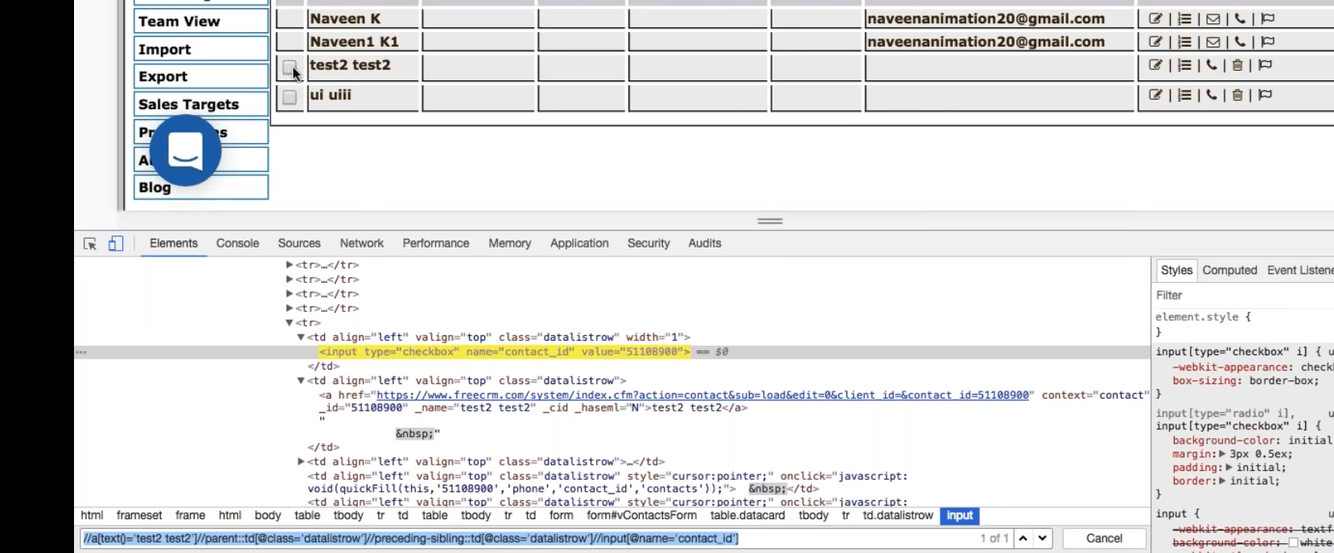

Chld to the parent

//a[text()=’test2 test2’**]//parent**::td[@class=’detailstrow’**]//preceding-sibling::**td[@class=’detailstrow’]//input[@name=’contact_id’]

**View: child 🡪 parent1 🡪 parent2 🡪 child2**

**//parent::**

**//preceding-sibling**